**Sprint - 3**

|  |  |
| --- | --- |
| Date | 17 November 2022 |
| Team ID | PNT2022TMID14015 |
| Project Name | Smart Fashion Recommender Application |

# Creating Chat Bot for application

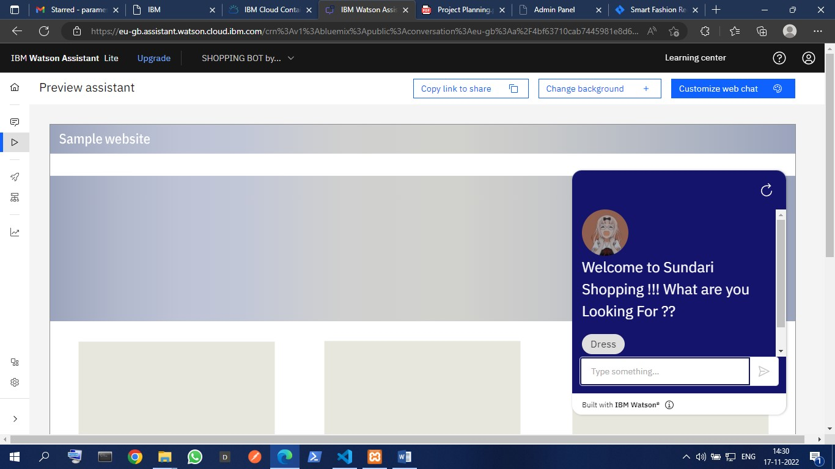

# Adding Features of Chat Bot

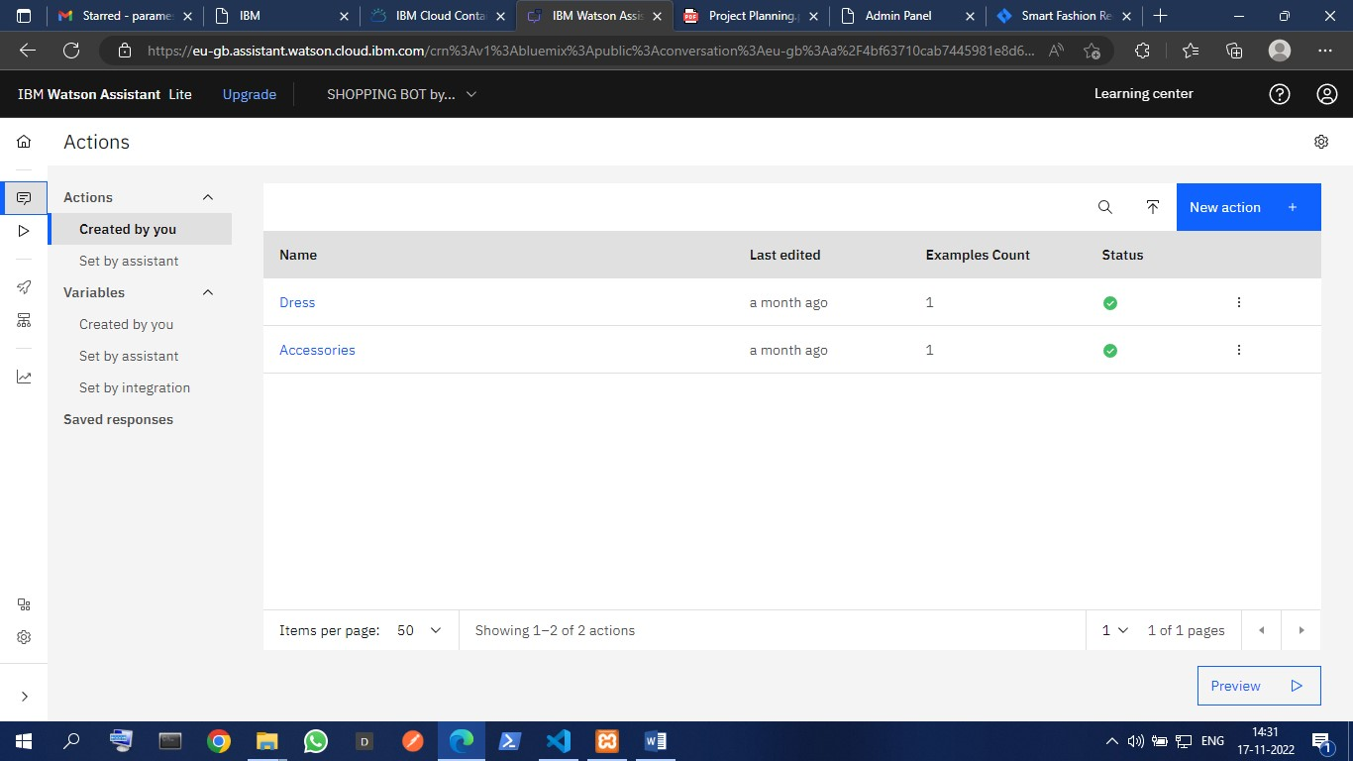

# Integrate Chat Bot with Web site

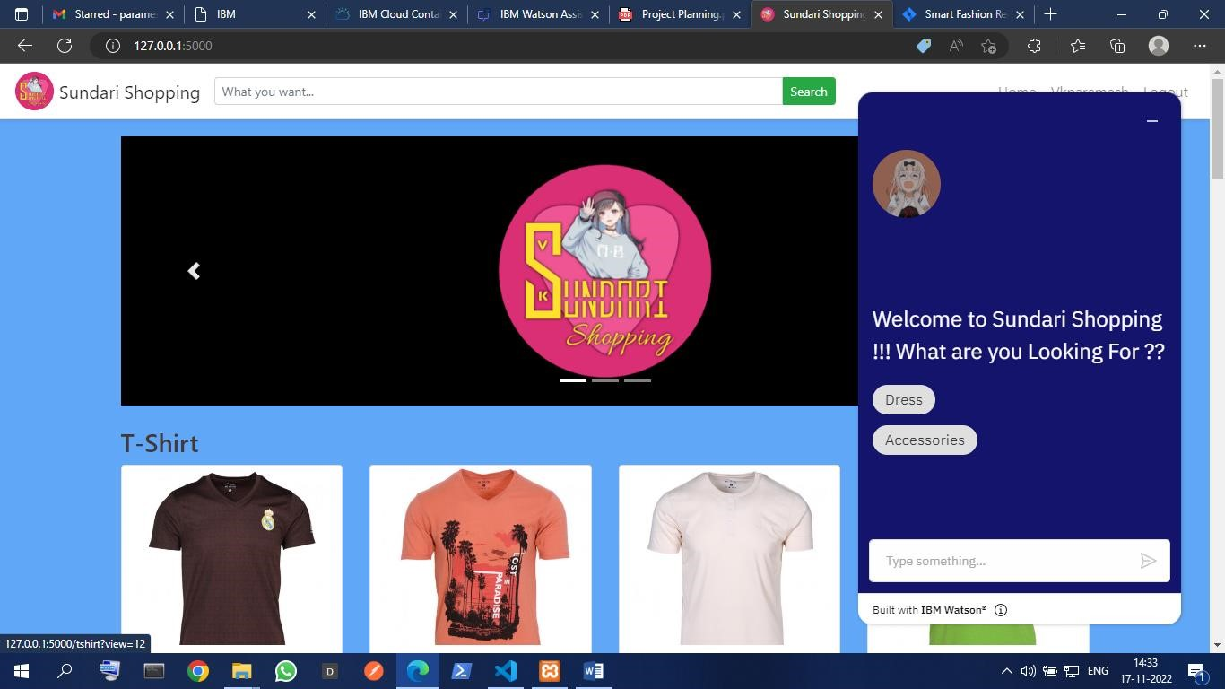

# Completing Chat Bot

